1. The two most opposing methods are Waterfall and Agile, if you know everything you want and simply need it realized quickly and at low cost, then we can use Waterfall. If you are unsure of any details but you have a base imagination then we will use Agile, it makes the frame and we communicate during the process to make features on the fly.

With those definitions, say we have a project to create a food delivery app for a restaurant owner. The Waterfall method might be preferred if the owner is only concerned with *having* an app up and running as soon as possible and needs the basic details such as display food options, show delivery options, placing orders through the app. The details are laid out and just need to be executed and approved periodically but changes aren't made to it. If the client wants this app but wants it to be more dynamic than a typical everyday delivery app, they might want the base made and then discuss with the team new features that can be added for any reason.

If asked which method would be more suitable, I would respond with Agile if money is no object, otherwise Waterfall if the benefits of a delivery app is greatly needed at this very moment.

1. AR table-tennis game
   1. Functional / Non-functional requirements:
      1. Must display within a VR goggle headset
      2. VR hand controls are tracked for the paddle
      3. Spatial arrangement to display and place table
      4. Sound feedback
   2. System / Software requirements:
      1. The ball can be tracked for win or loss counting
      2. Ball, table, paddle physics
      3. No lag for ball bouncing
      4. Portable between different VR headsets
      5. Cross headset compatibility play
      6. In real time play for all participants
   3. User stories:
      1. Design meshes for table, ball, paddle to be displayed. The objects should look recognisable.
      2. Add physics to said objects: ball should rest on top of table without falling through, paddle should move ball in a proper manner.
      3. Link objects to be viewed and controlled via VR headset and controls. The players should be able to see the table in front of them in the same location, the ball should move back and forth from the crontoler manipulating the paddle.
2. Performed activities:
   1. Scrum Master:
      1. Keep sprint backlog up to date
      2. Keep team following scrum framework
      3. Lead sprint retrospective
      4. ------
      5. Take the first item in the product backlog and assign it to the dev team. I will monitor their progress and mark the task as done or not depending on the deliverables and tests assigned to that task. I will then mark it and move onto the next and repeat as necessary. Keeping a log of completed user stories. Every day I will call a stand up to get reports on progress and once every few weeks a full meeting to reorganize the product / sprint backlog if necessary.
   2. Product Owner:
      1. Learn product backlog
      2. Owns collection of user stories
      3. Interaction with customer
      4. Understands customer needs
      5. Orders items in product backlog
      6. Keeps backlog clear for scrum team
      7. ------
      8. After receiving the user stories and having conversed with the client, I would order the user stories into High -> low priority to put into a product backlog. Most necessary thing is most likely letting people login at all, then having assignments, entering which assignments you want shown to you then being able to interact with them such as assigning a TA. Each task will be carried out in order and if any questions arise I will do my best to resolve them to the best of my knowledge of what the customer wants, otherwise i will set up a meeting with the customer to go over built up questions.
   3. Dev Team:
      1. A task will be given to me or I vote on which story I will be able to complete sufficiently. I then carry out the story and test it as instructed and report back to the Scrum Master.

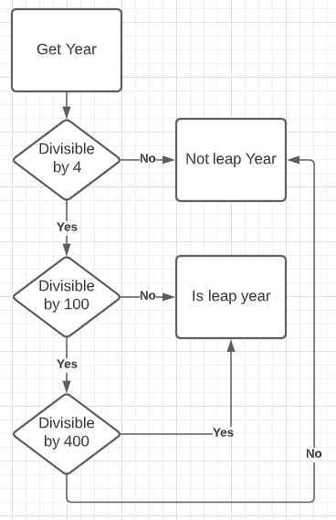

1. Get year, divide by 4, if divisible then divide year by 100, if divisible then divide year by 400, if divisible then the year is a leap year, else it is not.